**Sprint 3 Plan**

*Product:* $h0pLyf3 (Shopping List)

*Team:* Fantastic Five

*Sprint Completion Date:* Sunday, November 19, 2017

*Revision:* 1.0

*Revision Date:* November 6th, 2017

*Goal:* We are working to allow users to organize their recipes and ingredients as well as an actual shopping list, and to have basic functionality that stores unique user data in the database and can be listed out on the web app upon user login.

*Task listing:*

**User Story 1:** As a shopper, I want to be able to keep track of what I’m buying at the grocery store.

* Checkbox to keep track of what is bought/in cart (3)

**User Story 2:** As a shopper, I would like a shopping list to be generated from the recipes I have chosen so that I can save time creating a grocery list.

* Create backend to access recipes and pull ingredients SPECIFIC to each user (9)
* Backend to add ingredients and recipes SPECIFIC to each user (3)
* Create page view to select recipes for list (3)

**User Story 3:** As a shopper, I would like to be able to remove ingredients I have from my shopping list, so that I don’t buy extra stuff I don’t need.

* Figure out how to remove ingredients from page without removing from database (9)

**User Story 4:** As a shopper, I want to be able to add my own recipes as well as remove them.

* Create functionality to add/remove recipes on the backend (9)
* Create front-end to display recipes (3)
* Create front-end button to add recipes (3)
* Create front-end button to delete recipes (3)

*Team Roles:*

**Connor Thurmond**: Product Owner, Developer

**Nikolai Chen:** Developer

**Anna Lin:** Developer

**Andrew Gilchrist:** Developer, Scrum Master

**Michael Tang:** Developer

*Initial task assignment:*

**Connor Thurmond**: Create backend to access recipes and pull ingredients SPECIFIC to each user

**Nikolai Chen**: Figure out how to remove ingredients from page without removing from database

**Anna Lin**: Checkbox to keep track of what is bought/in cart

**Andrew Gilchrist**: Figure out how to remove ingredients from page without removing from database

**Michael Tang**: Develop backend to add ingredients to recipes

*Initial Burnup Chart:*

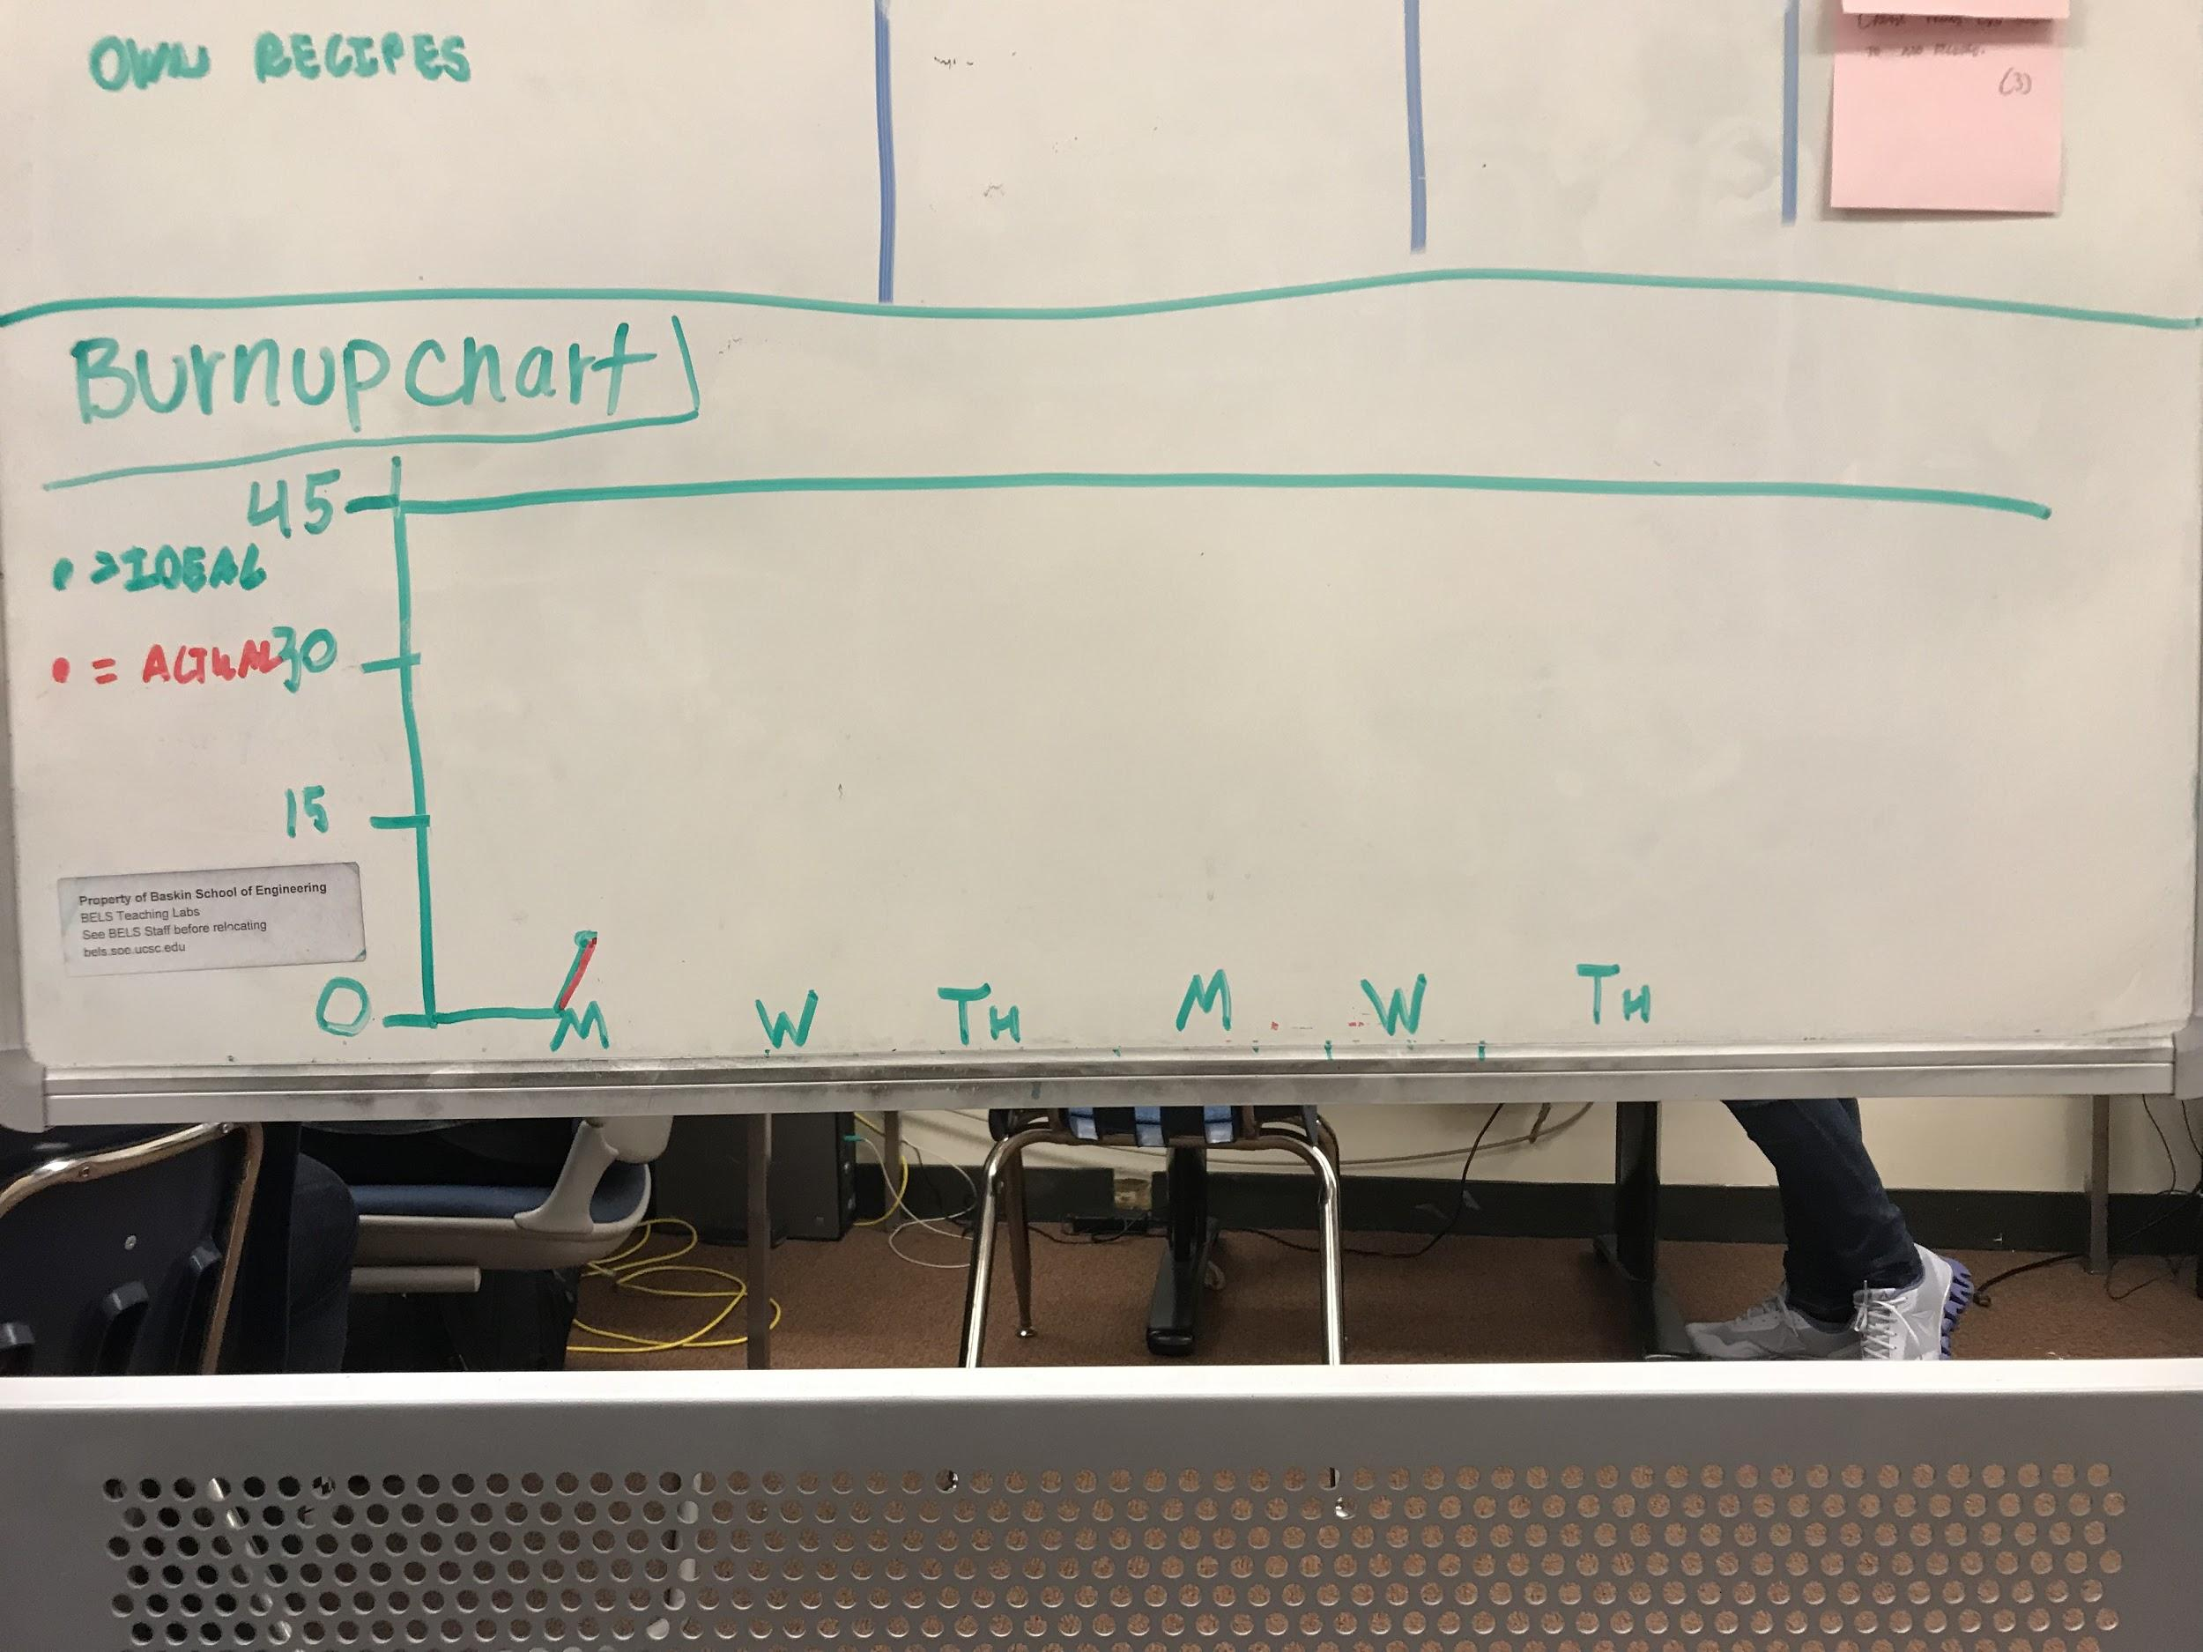

*Initial scrum board:*

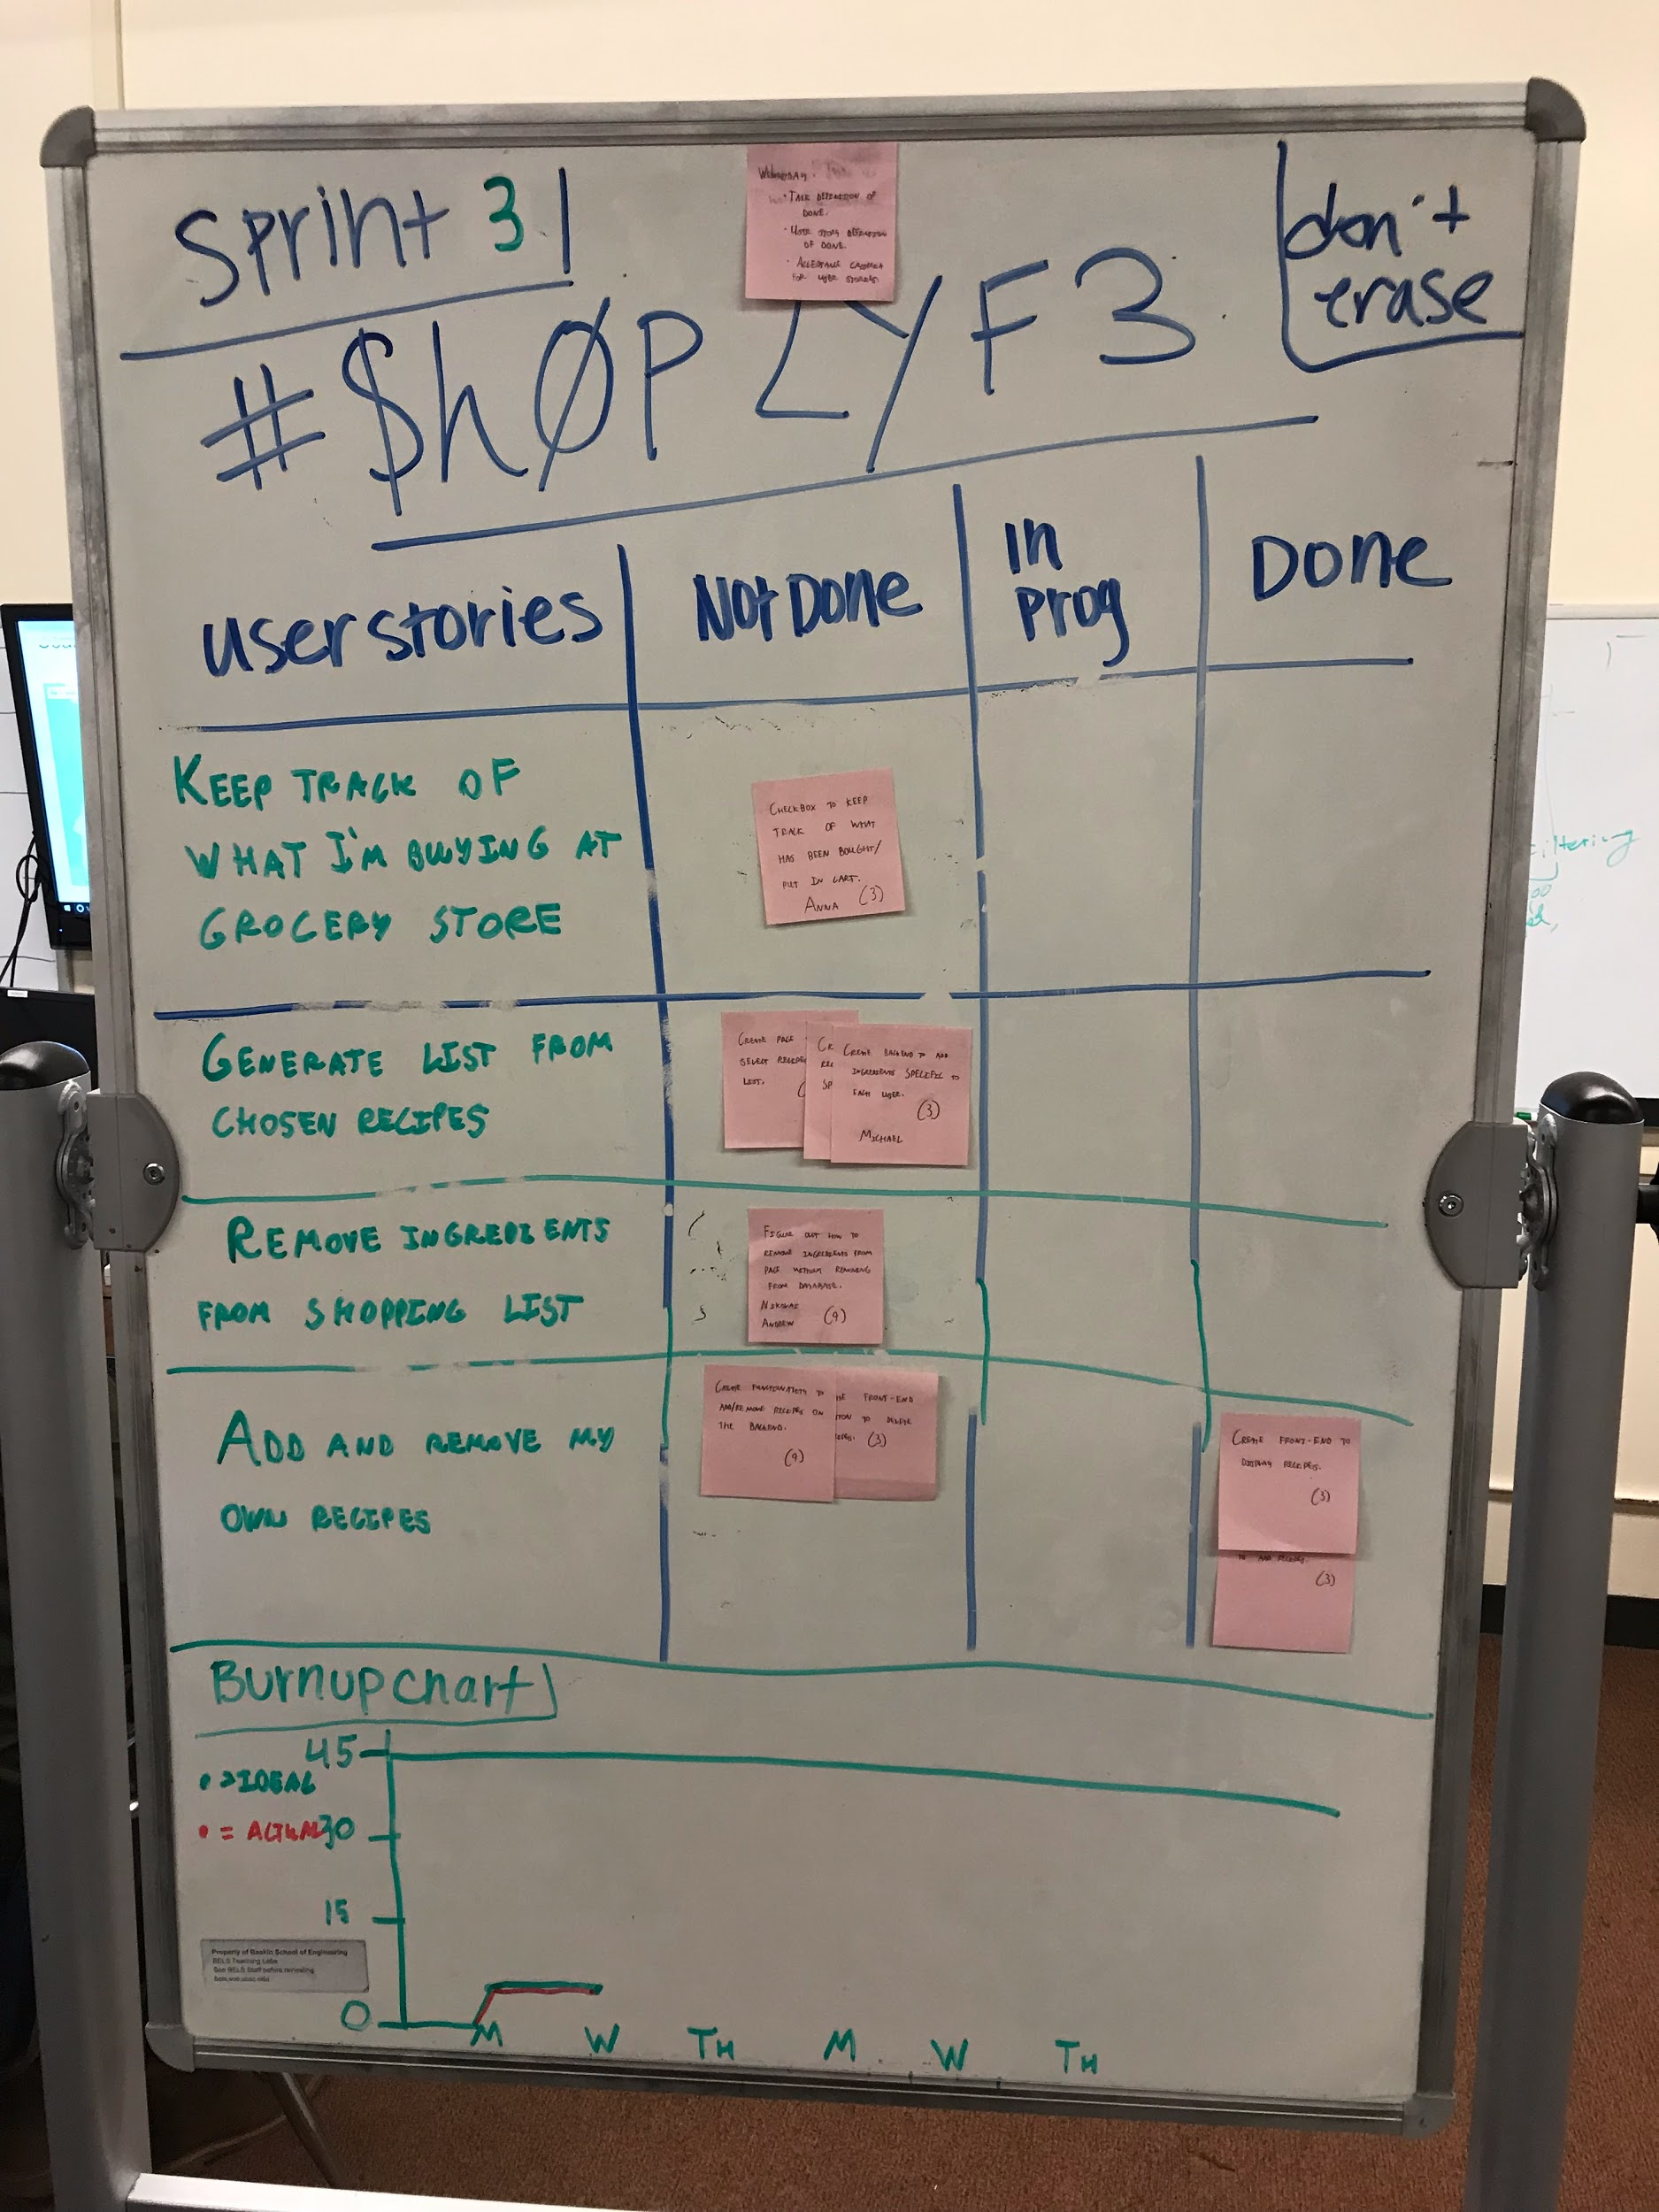

*Scrum times:* Our team will meet Monday and Wednesday from 10:45-12:00. We will meet with a TA on Thursday from 5:20 - 5:40.